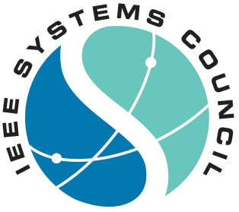
IEEE International Systems Conference 2018
April 23-26, 2018
JW Marriott Parq Vancouver
Vancouver, BC CANADA

CONTRACT FOR EXHIBIT SPACE

We hereby apply for exhibit space in the 2018 IEEE International Systems Conference in Vancouver, BC Canada to be held April 23-26, 2018.

Company Name:____________________________________________ Contact Name:____________________________________
Address: (please do not use P.O. Box #)__________________________________________________________________________
City:_______________________________State:________Province:______Postal Code:___________Country:___________________
Telephone: +_________________________________Ext. _________Fax: +______________________________________________
E-mail:____________________________________________________WebSite:__________________________________________

Exhibitor Guidelines:
1- Exhibit space is tabletop configuration, approx 8 ft x 7 ft. Backdrop “popups” are allowed.
2- One draped 6x2.5 table with 2 chairs will be provided.
3- Exhibits will be located in registration and breaks hall area.
4- Exhibit personnel will be expected to register for conference if full technical sessions are desired.
5- Power connections will be billed as incurred.
6- Exhibits may to be set up on Monday, April 23 between 1:00 p.m. - 5:00 p.m..
7- Exhibits tear-down will occur Thursday, April 26 at 11:30 a.m.
8- Space is assigned first-come, first served by conference committee.

Number of Tabletop Exhibits desired: ___________ @ $1,000.00 USD Total: $________________

Note: All applications must be accompanied by full payment in order to be included in tabletop allocation.
Tabletop Exhibits Allocation Process will begin on February 1, 2018

Method of Payment: _____Check _______ American Express _______ Visa _______ MasterCard______Discover
Make all checks payable to: 2018 IEEE International Systems Conference

Card Number: Exp. Date: _____/_____ CVV Security Code:_________

Signature__________________________________________________________________

Cardholder Billing Address: _____________________________________________________________________________________

City:_______________________________State:________Province:______Postal Code:___________Country:___________________

AUTHORIZATION
I am authorized by my company to contract for exhibit space at the 2018 IEEE International Systems Conference as indicated above. I have carefully read and accept the information and conditions contained herein.

Print Name:_______________________________________________________________ Date_______________________________

Signature:____________________________________________________ Title:___________________________________________

..................................................................................................................................................................................................................................................

Return completed form with remittance to Cynda Covert, IEEE SysCon 2018
1210 NW 14th Ave, Gainesville FL 3260
Email: ccovert@conferencecatalysts.com
Ph: + 1 352-872-5544 Fax + 352-872-5545

