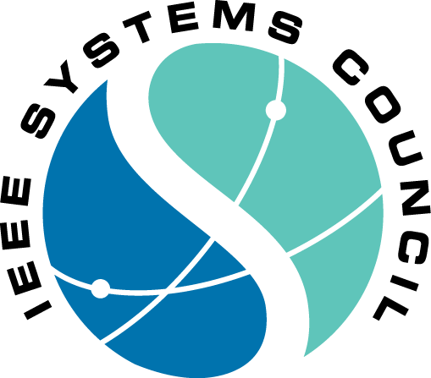

2018 IEEE International Systems Conference

April 23-26, 2018

JW Marriott Parq Vancouver

Vancouver, Canada

Contract for Promotional Sponsorship

All patrons receive:  • Logo and write-up on the IEEE SysCon 2018 website with link to company website  • Recognition as a Patron at the entrance of the Conference  • Corporate information in Conference bags  • Recognition at award event  • Priority location in exhibit area | Check (X) | Amount
Platinum Patron  Includes: Literature in Tote Bag, Prominent logo & write-up on Website, Signage at the Tuesday Night Reception (32x48), Signage in the Registration area (32x48), Signage at Coffee/Beverage Breaks (22x28), Full-page color advertisement in Conference Final Program, 1 exhibit personnel, ONE FULL REGISTRATION, ONE FREE EXHIBIT TABLETOP |  | $3,000.00
Gold Patron  Includes: Literature in Tote Bag, Prominent logo & write-up on Website, Signage at the Tuesday Night Reception (32x48), Signage in the Registration area (32x48), Signage at Coffee/Beverage Breaks (22x28), Half-page color advertisement in Conference Final Program, 1 exhibit personnel, ONE FREE EXHIBIT TABLETOP |  | $2,000.00
Silver Patron  Includes: Literature in Tote Bag, Prominent logo & write-up on Website, Signage at the Tuesday Night Reception (32x48), 1 exhibit personnel, ONE FREE EXHIBIT TABLETOP |  | $1,500.00
Additional Opportunities
Tote Bag – Logo on Bag |  | $1000.00
Full Page ad in Program |  | $750.00
Half Page ad in Program |  | $500.00
Conference Bag Literature |  | $500.00
 | Total:

Company Name: |  |  | Contact Name:
Address:
(Do Not Use P.O. Box #)
City: |  |  |  |  |  | State:
Province: |  |  |  | Postal Code:
Country:
Telephone: |  | Fax: | E-mail: |  |  |  |  | Website:

Method of Payment: | Check | Wire Transfer | American Express | Visa | Master Card
(Make checks payable to 2018 IEEE International Systems Conference)
Account:__________________________________________ Exp. Date: __________________ Card Security Code:___________________________________
Billing Address:________________________________________________________________________________________

Authorization: I am authorized by my company to contract promotional items at IEEE SysCon 2018 as indicated above.

Print Name:___________________________________ Signature: ____________________________________________ Date: __________________

RETURN COMPLETED FORM AND REMITTANCE TO
Cynda Covert IEEE SysCon 2018
1210 NW 14th AVE Gainesville, FL 32601
E-mail: ccovert@conferencecatalysts.com
Telephone: | +1 (352) 872-5544 | Fax: | +1 (352) 872-5545

